How to file your weekly certifications for Unemployment Benefits
Opening a new unemployment claim prepares you for receiving unemployment benefit payments, but you won’t receive them unless you are otherwise eligible AND you tell the department that you are unemployed and seeking payment. This is called “certifying” for weeks of unemployment or referred to as “weekly filing.” To certify for one or two weeks at a time, you will log into your Pennsylvania unemployment dashboard and follow the instructions in this guide.
To file a weekly certification, scroll down and locate the “File for Weekly Benefits” hyperlink that appears in the center column under the “Unemployment Services” tab.
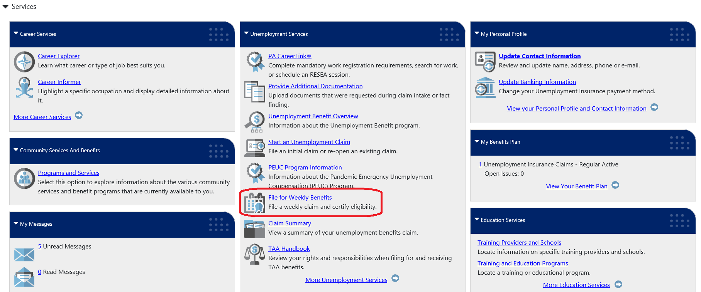

If you have previously certified for any weeks, they will be listed in the Weekly Certifications Review table. Click the “File Your Weekly Certification” button to begin the certification process.
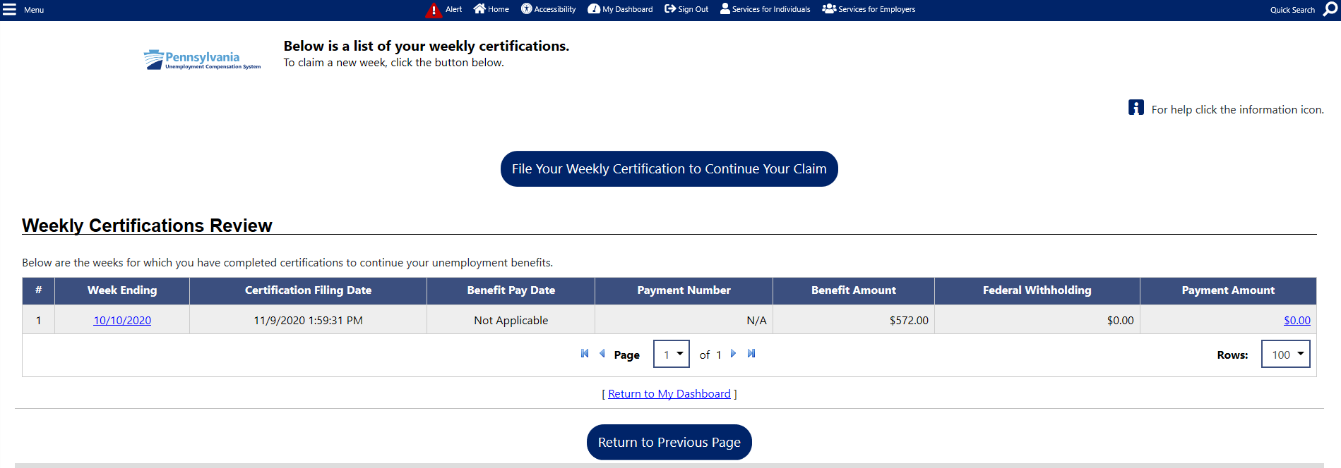

After the explanation of certification, click “Next.”
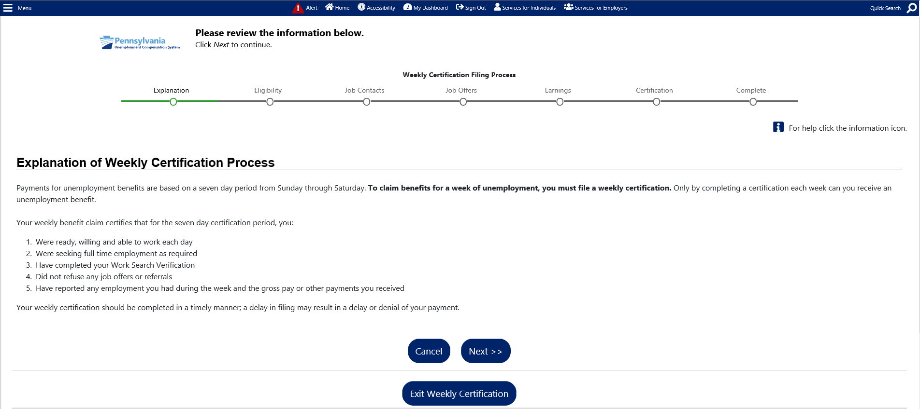

You will then be required to acknowledge that you have read and understand the information regarding potential fraud penalties.
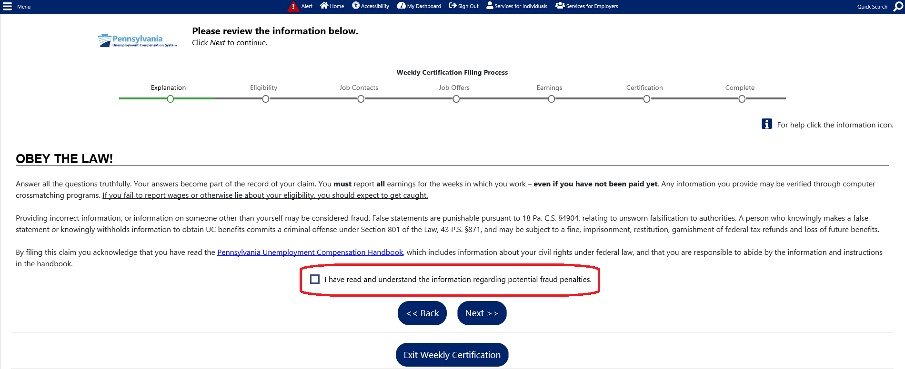

Next you will be provided an opportunity to update your contact information if it has changed. Use the “Update Contact Information” hyperlink if your address, telephone number or email address has changed.
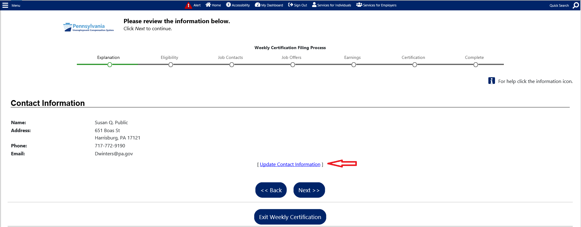

You will be shown the date for which you are filing. The answers you provide must go along with your situation for that calendar week.
If you prefer to file your certification every two weeks, you are not able to decline filing for the first week to move to the next. You must answer the questions for week #1 to get to week #2. If you do not wish to collect payment for a week due to full-time work, you will be given the opportunity to report this information in your claim for that week. If you do not wish to collect payment for a week due to being unable or unavailable to work, you will be given an opportunity to report this information in your claim for that week.
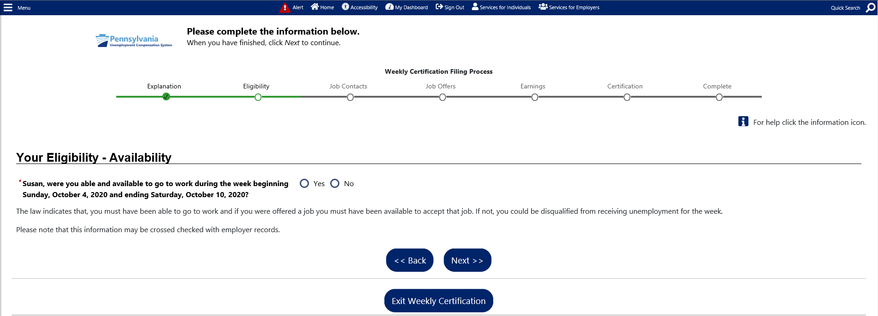

Answer “Yes” to the question regarding New Self-Employment/Sideline Business only if you have started new self-employment during the claim week in question OR if you had a sideline business and increased your participation during the claim week in question.
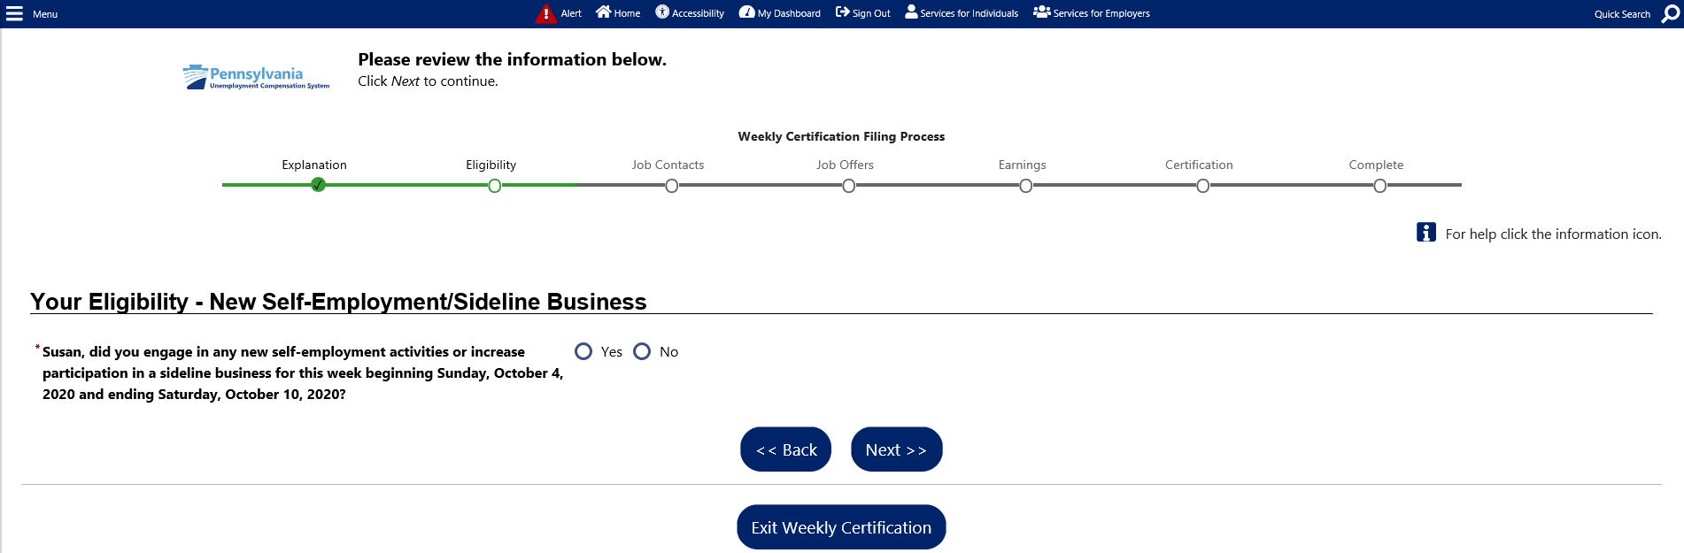

Absence from work, when work was available, includes situations when you will not be paid for periods of time when you were late to work, left early, called off sick or refused/did not show up for a shift.
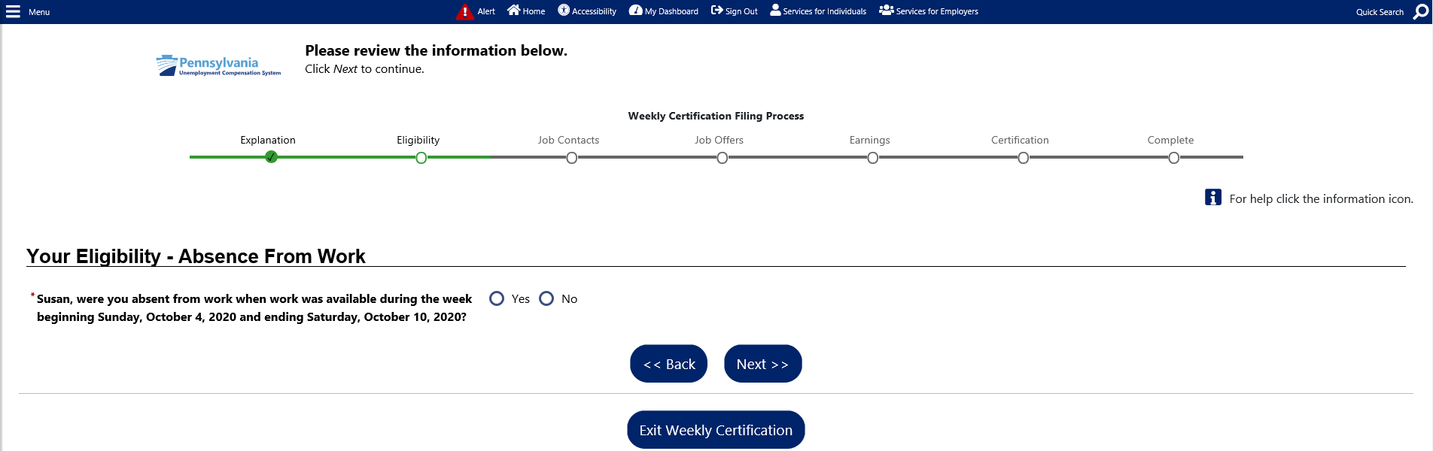

You are required to search for work and perform work search activities in accordance with the instructions provided in the UC handbook.
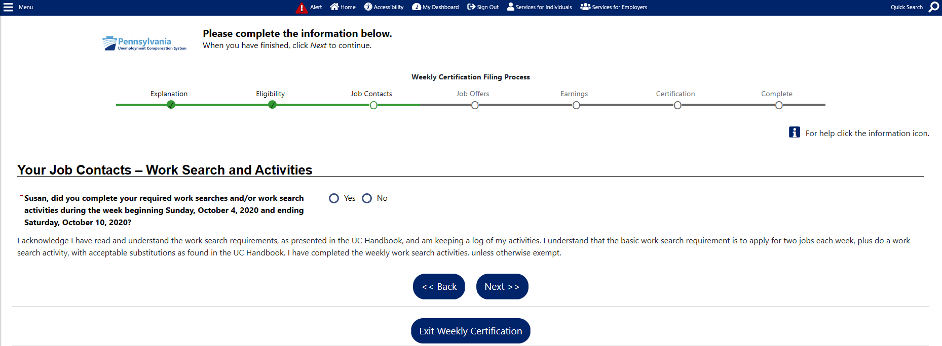

You must report any offer of work that you did not accept. The department will determine if that offer was a suitable job offer.
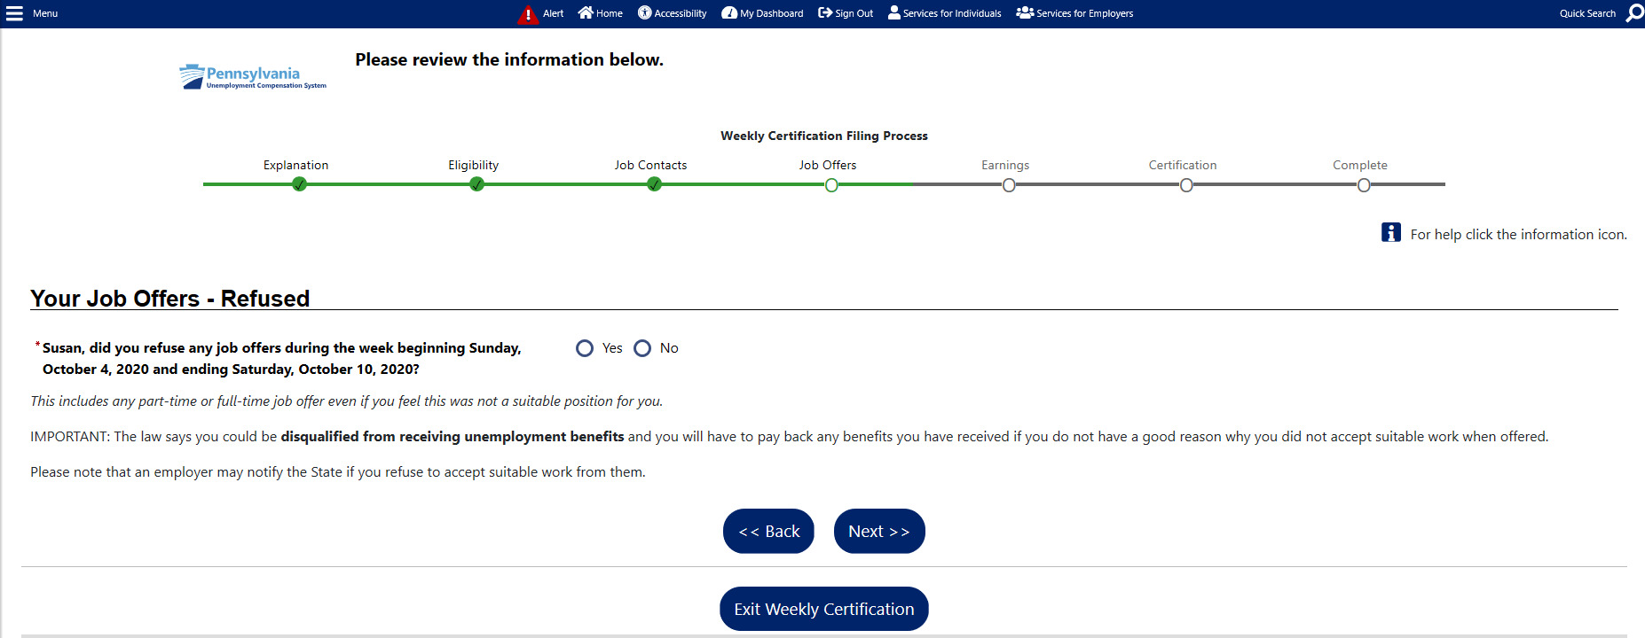

Vacation/Holiday/Other Earnings
Important: If you have earned any wages during the week including regular pay, commissions, tips, vacation/holiday pay, potential earnings (absence hours), paid sick time or any other payment based on your previous work, click the “Yes” button to report that information. Click here for more information about reporting earnings.
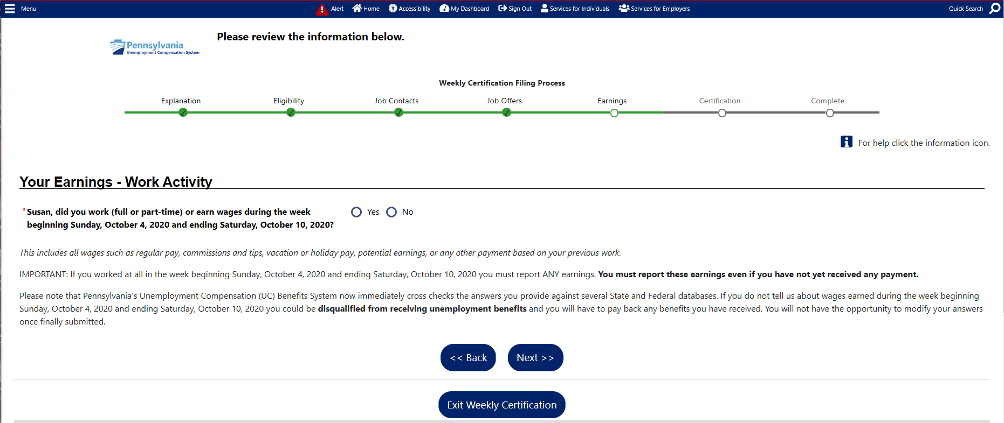

When you indicate that you worked or earned wages on the previous screen, you will be asked if you worked your normal full-time hours during the week for which you are filing.
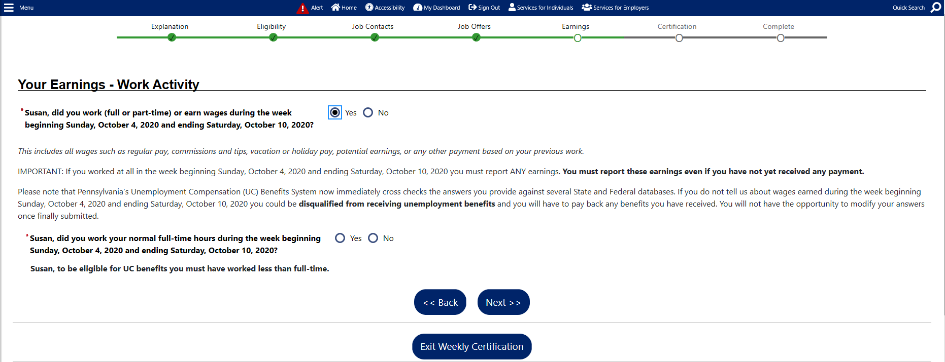

Next you will indicate the employer for which you worked. The employer may already be available on the menu, or you may click the box to enter the employer information.
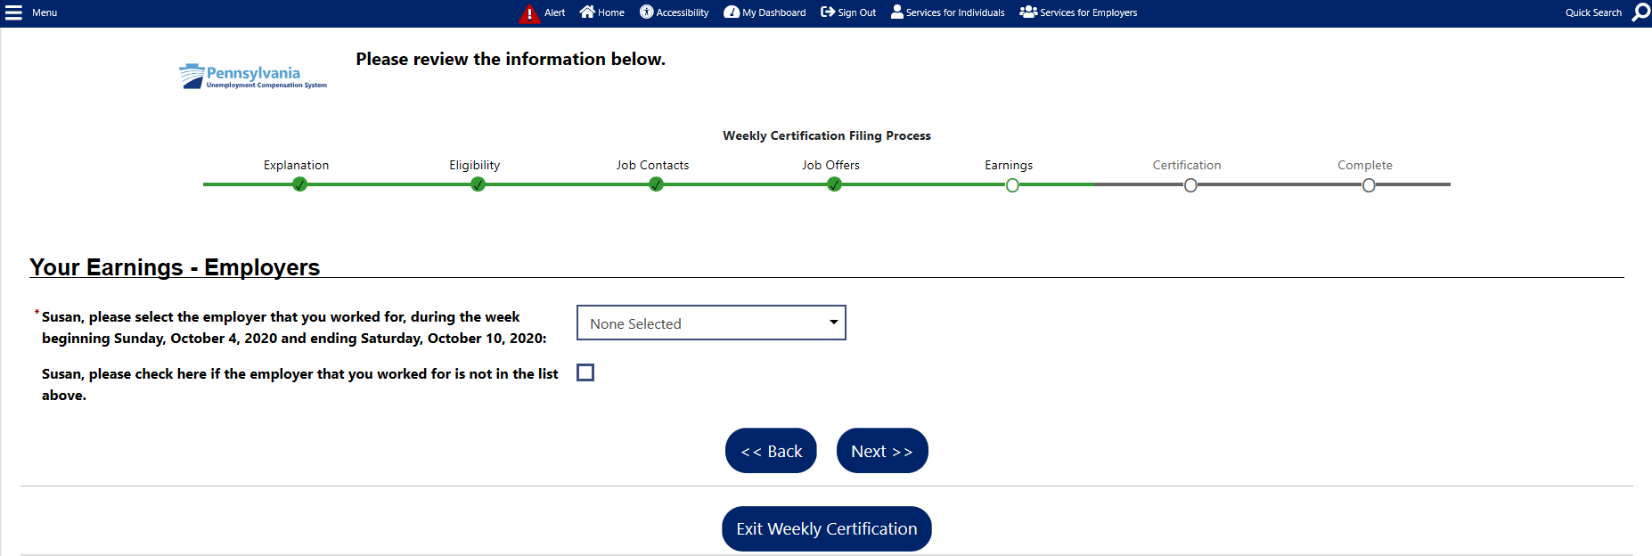

When you choose an employer from the drop-down menu, the employer information will be shown on the next screen. You may need to enter a telephone number for the employer.
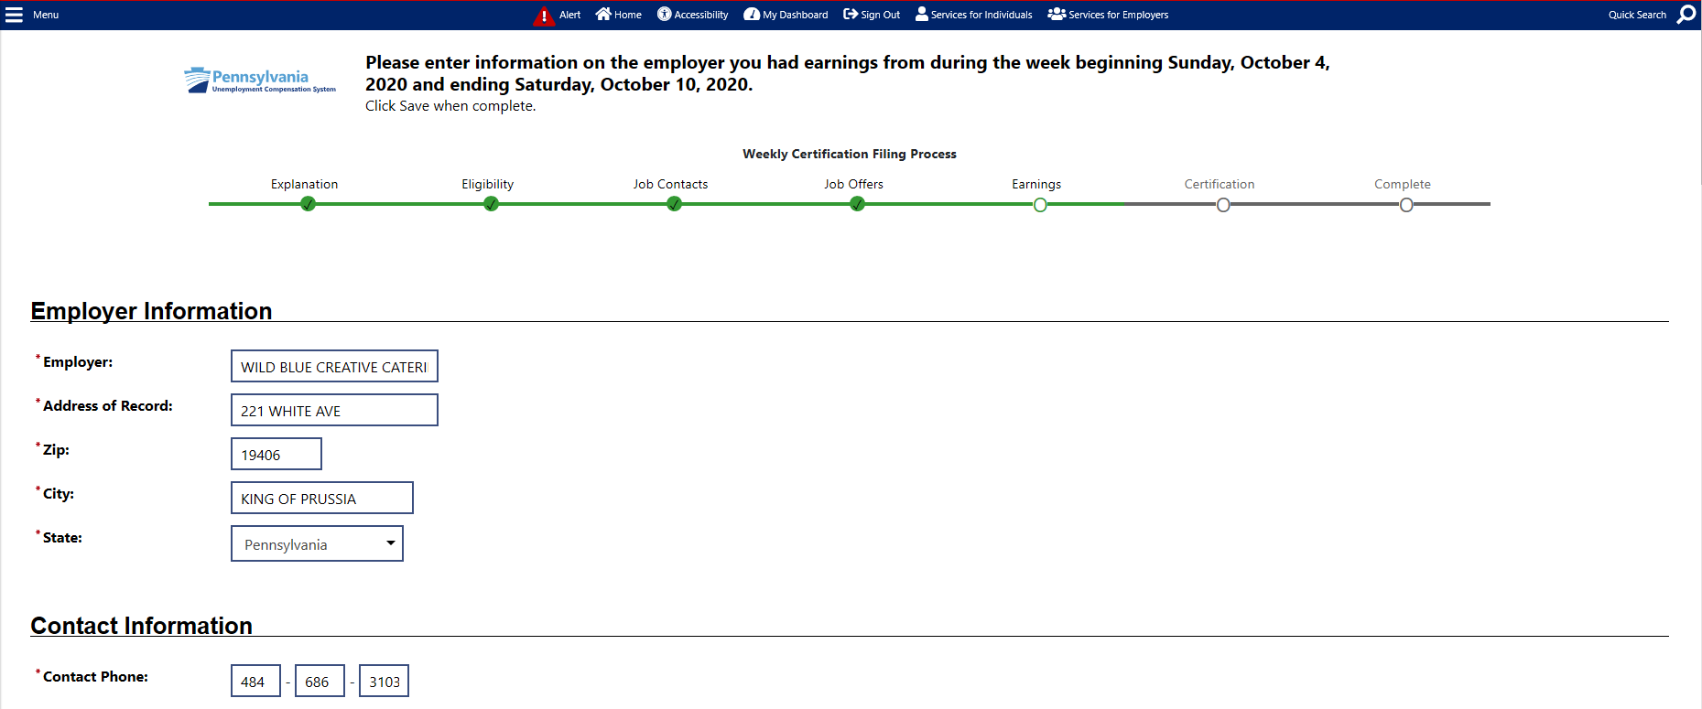

On the same page, you will be asked about your job title and job information.
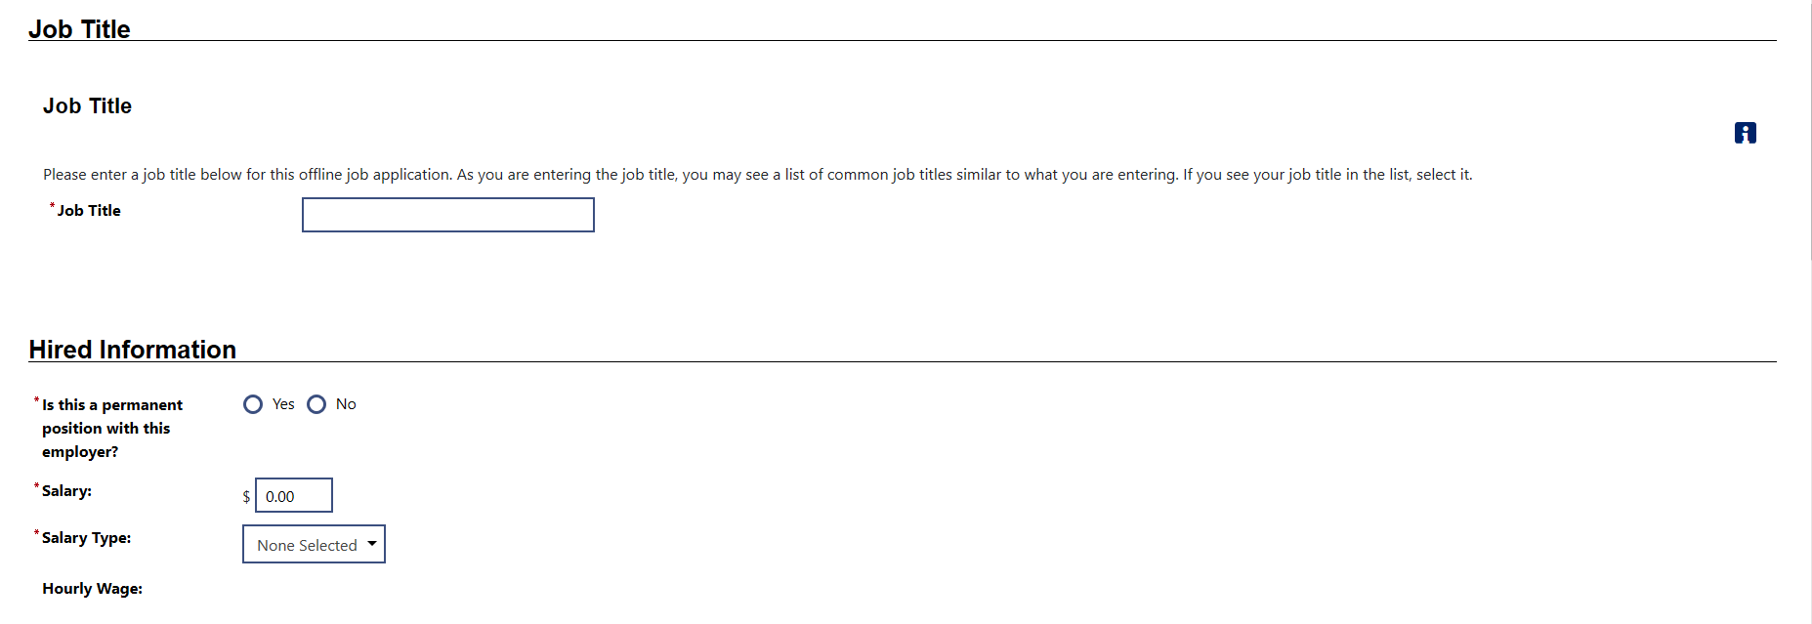

You will then be asked to enter all gross wages, by category, including Potential Earnings if work was available, but you were absent.
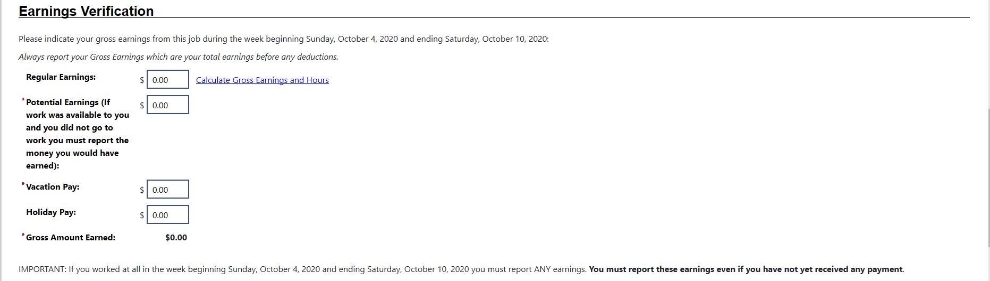

At the bottom of the page, you will be asked which days of the week you worked.
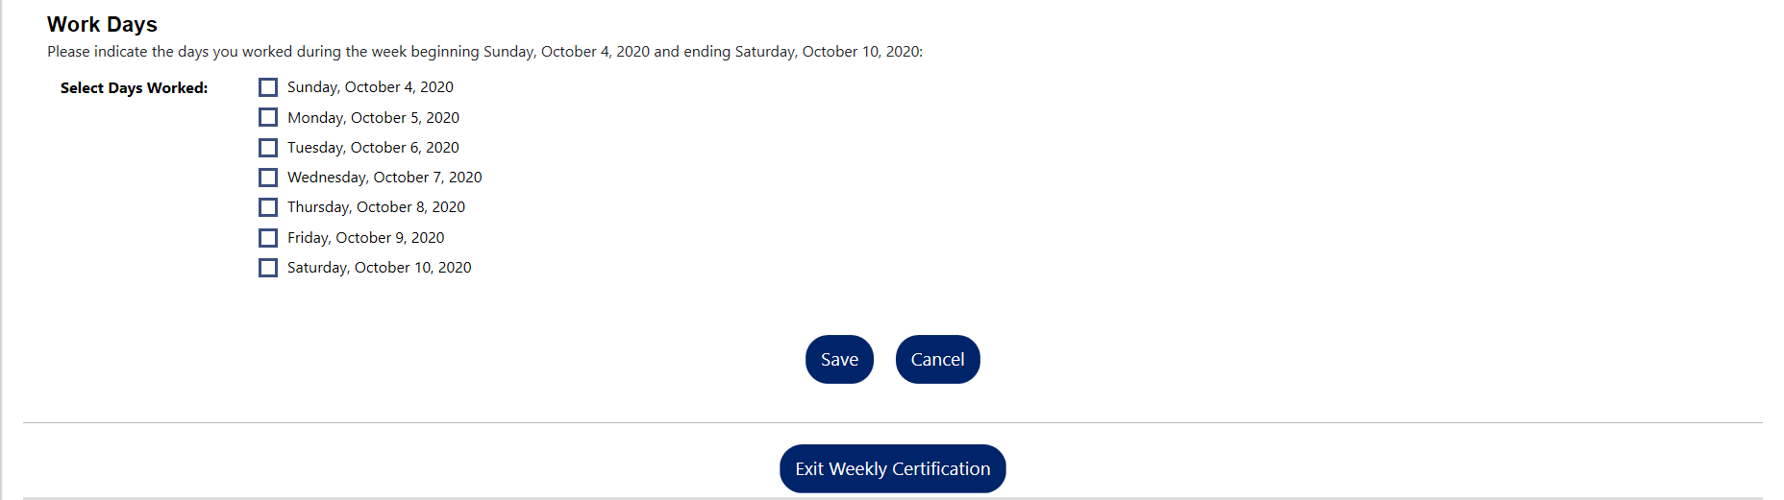

Once you have completed entering the information, you will be shown a confirmation of the wages provided. If you have earnings for another employer for the same week, click “Yes” to enter the next employer information and earnings.

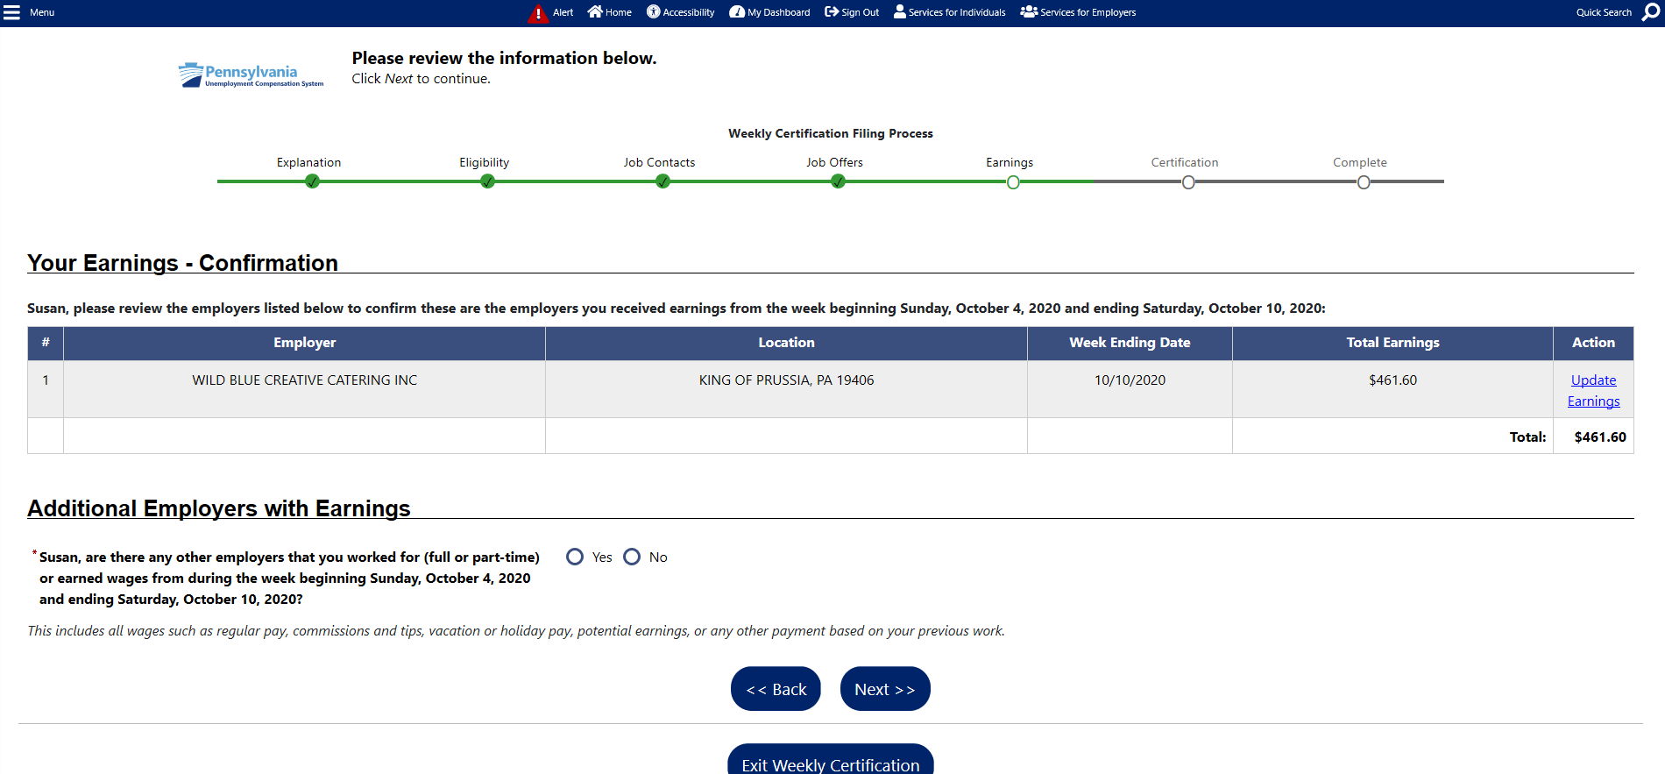

Depending on how you answer the questions during the weekly certification, you may be asked additional questions. For example, if you indicated that you received vacation pay (i.e. PTO) during the certification week, you will be asked additional questions. The first set of questions will be about the employer from which the vacation pay was received.
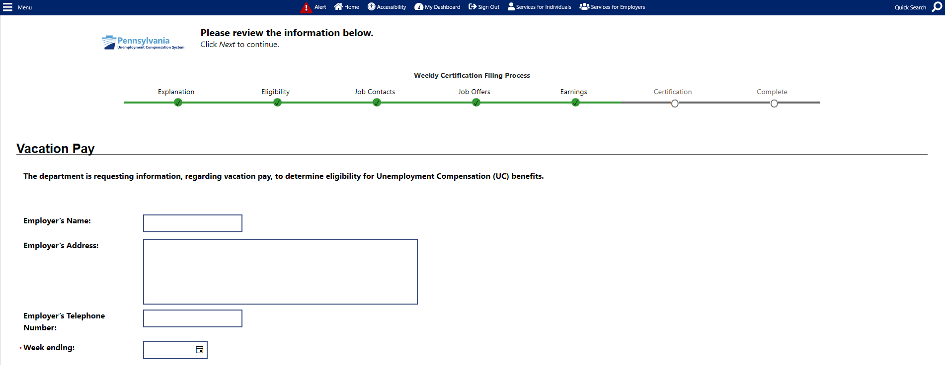

The next questions are regarding the vacation pay amount and if you have an Expected Date of Return to work.
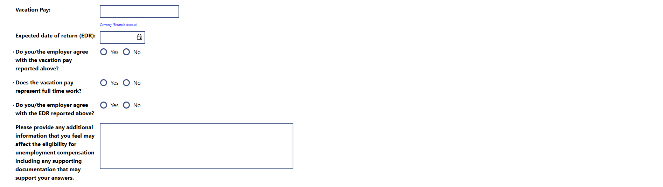

The final items on the page are acknowledgements.
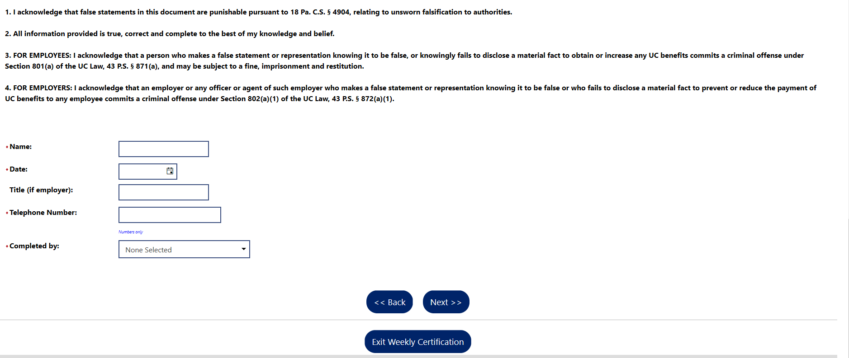

After all questions for the weekly certification have been answered, you will be able to review your answers.
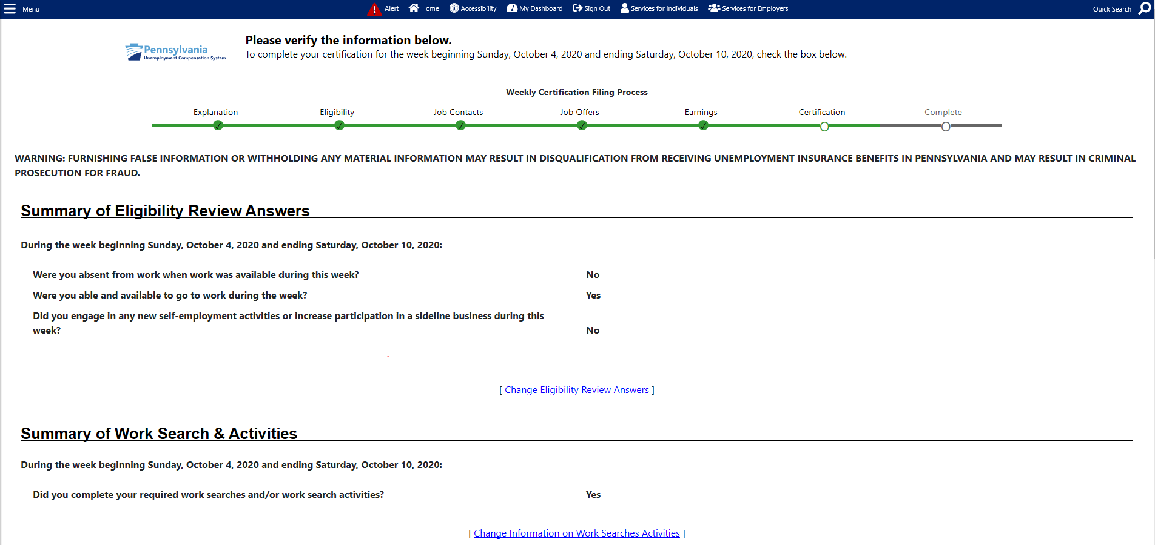

You may edit your answers if any information has been entered incorrectly up to this point. After the weekly certification is submitted, you will not be able to change any answers.
You will again acknowledge that you have read and understand the information regarding potential fraud penalties, before clicking “Next.”
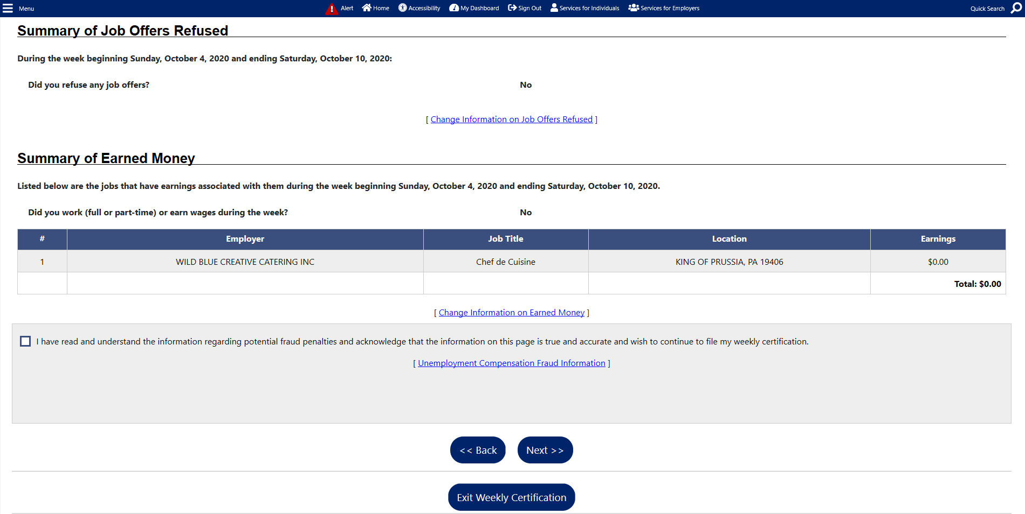

You have now completed the weekly certification questions for that week. If more weeks are available for certification, you may click “Yes, I would like to continue.”
If this is your first week filing your weekly certification, normally you will not be paid because the first week is a waiting week. You will be paid the amount for which you are eligible for all weeks after the waiting week.
UC Live Chat UC Email: UChelp@pa.gov
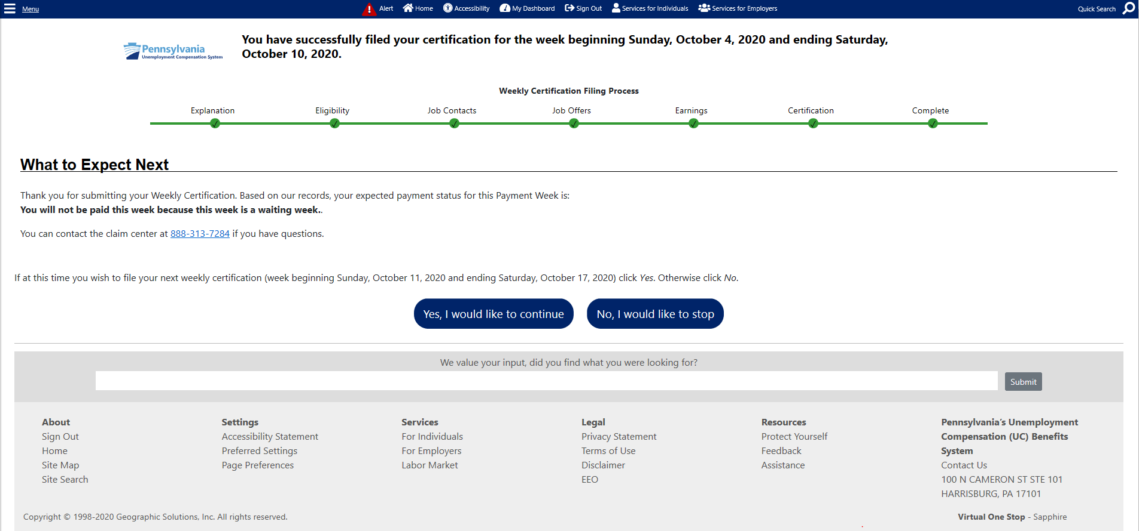
Clicking on “No, I would like to stop” will provide a claim summary.
