Overpayment Management

When you access your claim, the below window will display if you have messages and/or an overpayment.

If you would like to pay your overpayment with a debit or credit card, click on the hyperlink “Click here to make your payment.”

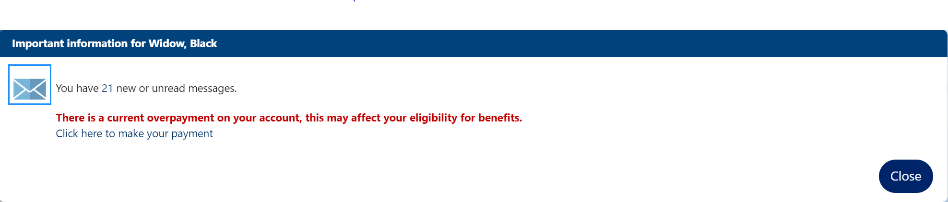

To view your overpayment, click on the menu located at the top left of the screen.

A flyout menu will appear and under “Services for Individuals,” select “Unemployment Services.” The second flyout will appear and you will select “Overpayment of Benefits.”

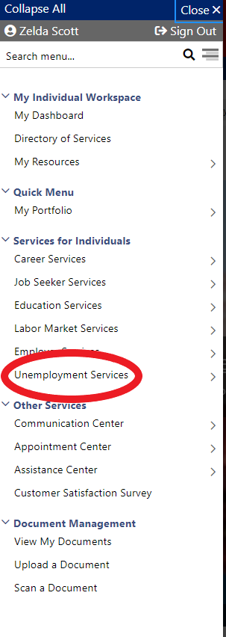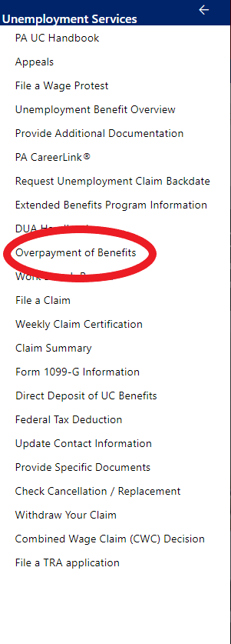
After selecting “Overpayment of Benefits,” the system will display the “Unemployment Insurance Claim Information” screen. From this screen, you can scroll down to the following screens: “Overpayment Amount Summary,” “Overpayment Details,” “Overpayment Penalty Week Detail,” “Out of State Overpayments,” “PA Overpayment Recovery Notice – IB-8606,” “Overpayment Determinations,” “15% and/or Penalty Week Determinations,” and “Overpayment Repayment Refunds.” These screens provide all the information you need to know about your overpayments and “recoupment,” which refers to recovery of the overpaid amounts.

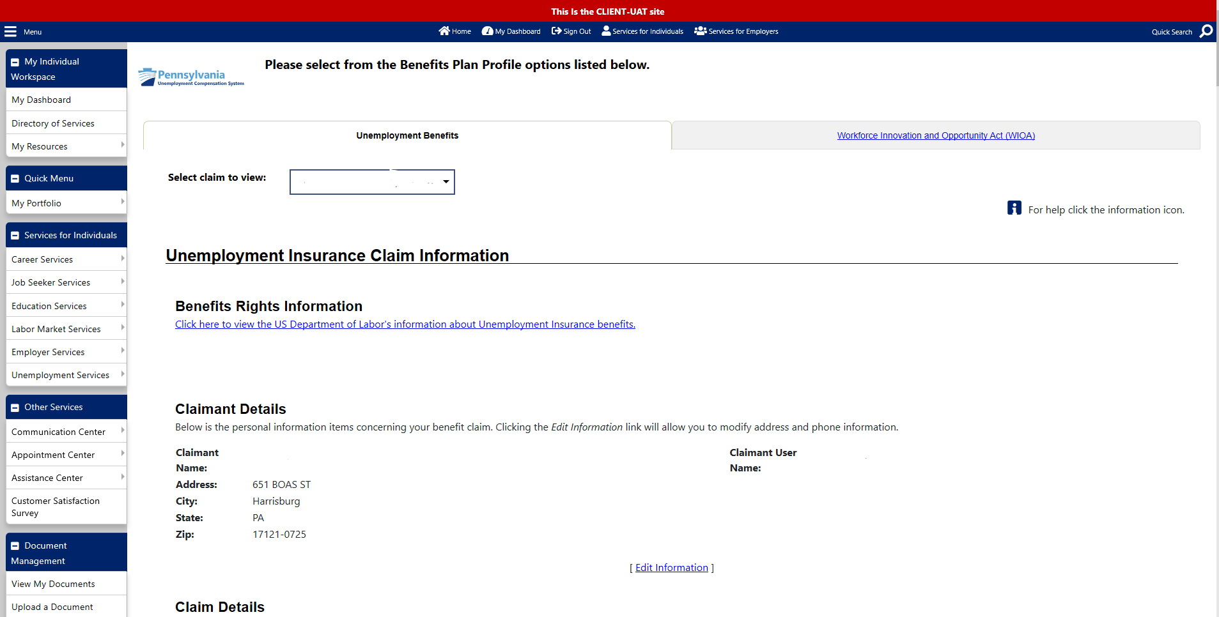

Overpayment Amount Summary

The Overpayment Amount Summary displays all activity involving your system-generated overpayments. If you would like to pay your overpayment with a debit or credit card, click on the hyperlink “Click here to make your payment.”

The fields on this screen are:

- Total Overpaid Amount – Increases with each new overpayment.

- Total Amount Recovered – Total amount of benefit offsets and payments made toward the overpayment.

- Total Amount Cancelled – Overpayments with cancelled Case Dispositions.

- Total Amount Waived – Overpayments with waived Case Dispositions.

- Total Amount Written Off – All overpayments without liens and outstanding prosecution cases beyond the statute of limitations for recoupment.

- Total Amount Refunded/Pending – Pending credits or refunds.

- Total Outstanding Balance – Total Overpaid Amount minus the Total Amount Recovered.

- Total Assessed Balance – All overpayments that the department can recoup.

- Total Number of Overpaid Weeks – The number of overpaid weeks. A breakdown by week displays in the Overpayment Details panel. If only an IRORA overpayment exists, the total number of overpaid weeks will equal zero.

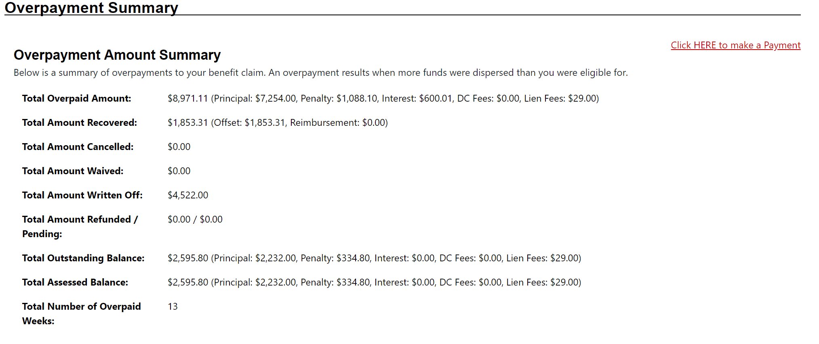

Overpayment Cases

The Overpayment Cases screen lists all the overpayments associated with the claim.

- Case # - Identifies each overpayment.

- Claim # - This number was assigned when the claim was established.

- Established/Assessment Date – The Established Date is the date the overpayment was written. The Assessment Date is when the department can begin to offset the overpayment with benefits. If you were assessed penalty weeks, you will see “PWK: #/#”, the first number is how many you were assessed, and the second number is how many you have left to serve.

- Status – The “Status” column displays the current status of the overpayment, such as an “Active,” “Written Off,” or “Prescribed” overpayment. It will also display any actions taken on that overpayment, such as a “Prosecution” or a “Lien.”

Options you may see are:

  - Active – Overpayments within the statute of limitations for recoupment, overpayments/liens beyond the statute of limitations for recoupment, and prosecution cases.
  - Written Off – Overpayments past the statute of limitations for recoupment.
  - Cancelled – Reversal of an overpayment.
  - Waived – Repayment of an overpayment is not required since it was not your fault and repayment would be a financial hardship.
  - Prescribed – Past the statute of limitations for recoupment (prescription date).
  - Deceased.
  - Dismissed – A bankruptcy court order was dismissed which allows us to continue to recoup the overpayment.
  - Bankruptcy Discharged – A reduced overpayment due to a court order.
  - Pending (rare).
  - Pending Written Off (rare).

- OP Type – Type of overpayment.

- Established Amount – Total of the overpaid claim weeks (CWE).

- Penalty – A 15 percent penalty assessed against the outstanding principal.

- Total Amount of Interest – Total amount of interest accrued monthly.

- Fees – DC = Dishonored check penalty, Lien = Lien filing fee.

- Total Remaining Balance – Total balance left to collect on each overpayment.
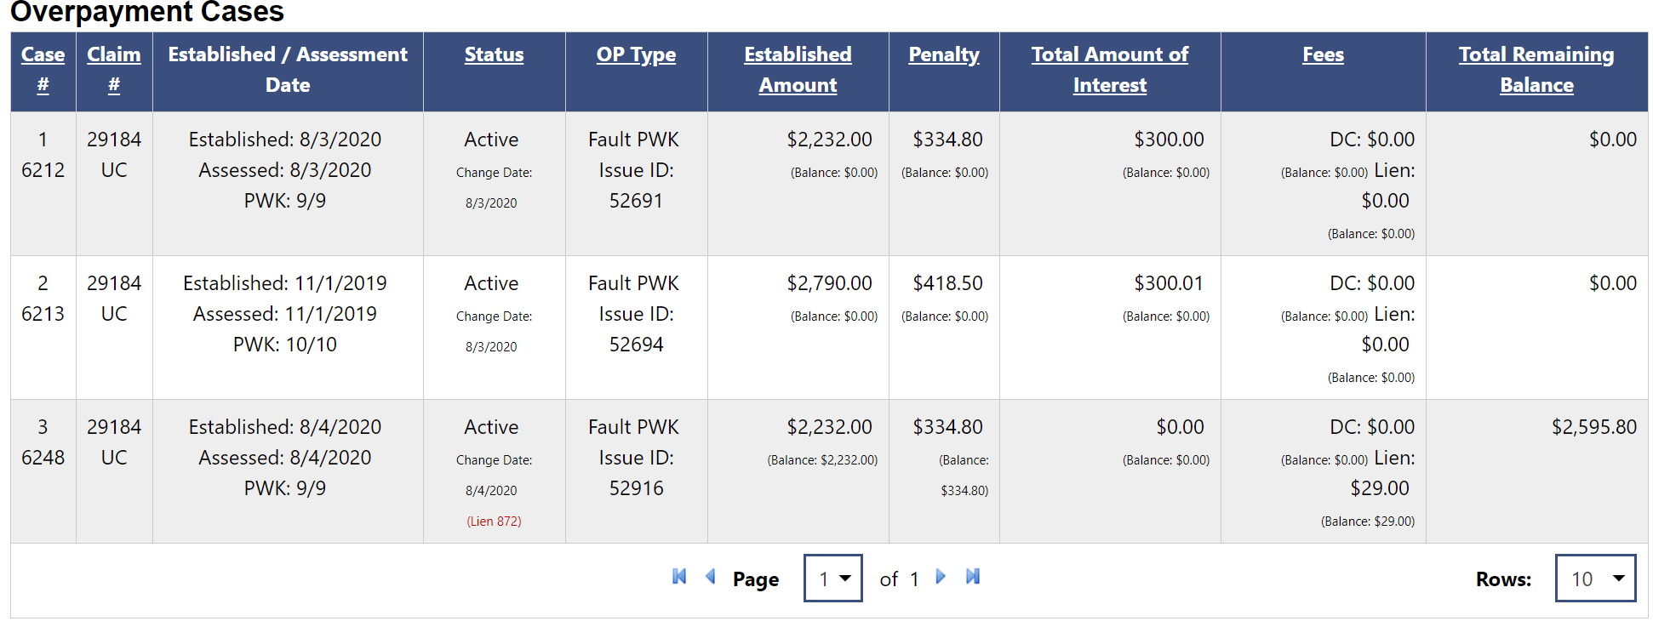

Overpayment Details

The Overpayment Details screen breaks down the overpayments and makes it easy to see the weeks assigned to each overpayment case number. Interstate Reciprocal Overpayment Recovery Arrangement (IRORA) overpayment cases will not be listed here; see the Out of State Overpayments panel.

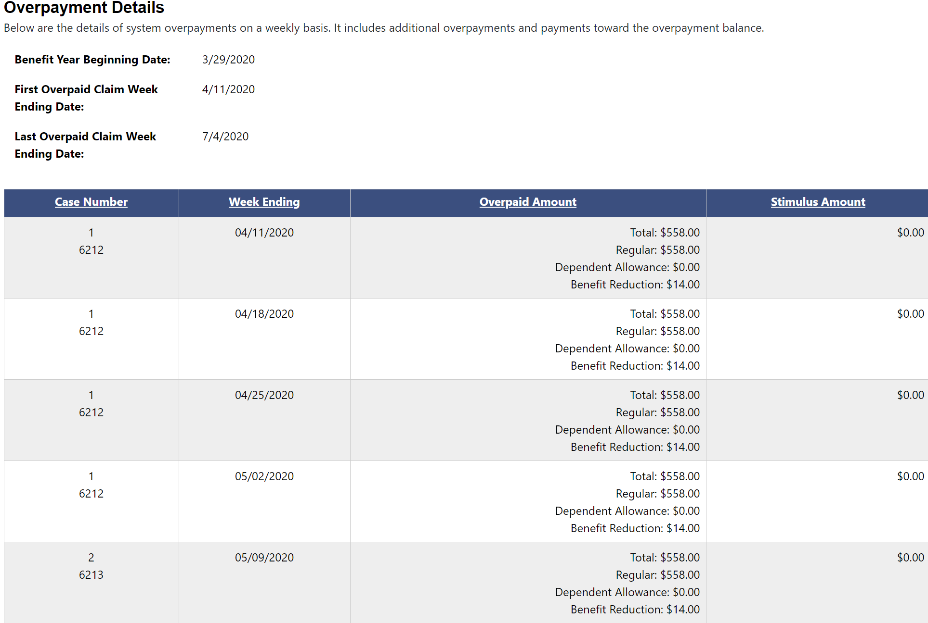

Overpayment Penalty Weeks Detail

The Overpayment Penalty Weeks Detail screen is a breakdown of penalty weeks assessed on each overpayment.

- Case Number – Identifies each overpayment.
- Claim # – Number assigned when the claim was established.
- Claim BYB – Benefit year beginning date of the claim.
- Claim BYE – Benefit year ending date of the claim.
- Penalty Week Begin Date – First date that penalty weeks can be recouped.
- Penalty Week End Date – Last date that penalty weeks can be recouped.
- Penalty Week Assessed/Outstanding – The original and outstanding number of penalty weeks that you must serve before you can receive benefits.

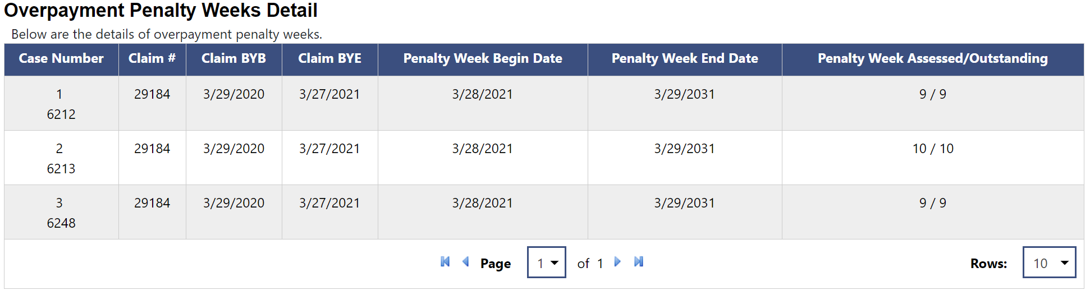

Out of State Overpayments

The Out of State Overpayments screen shows IRORA requests from other states asking Pennsylvania to recoup claimants’ overpayments for them.

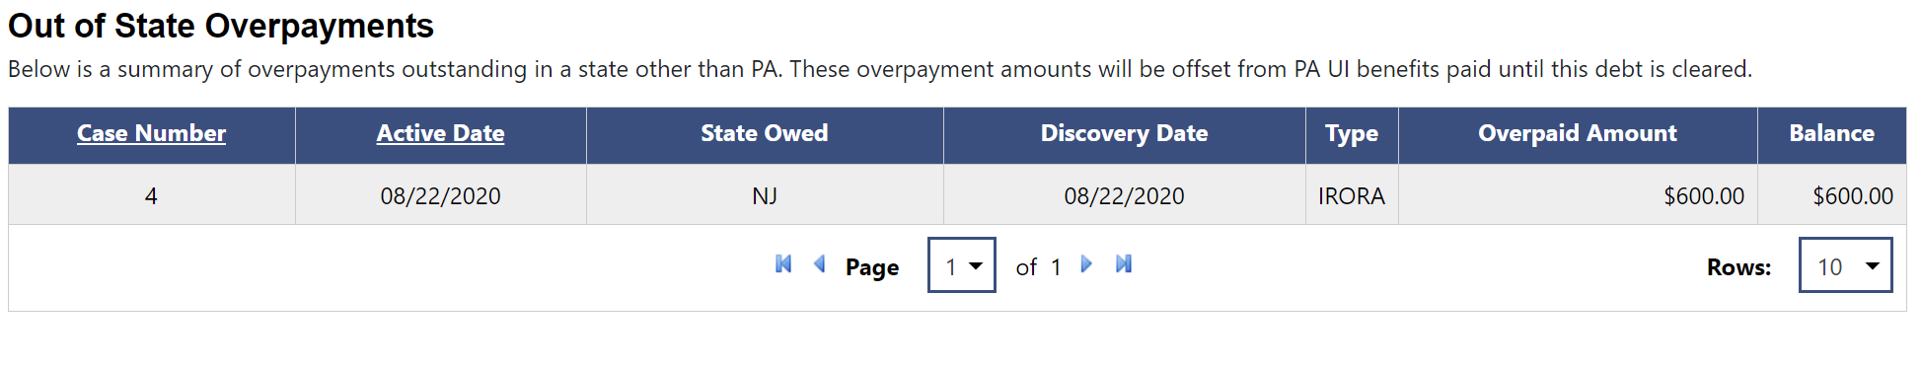

PA Overpayment Recovery Notice – IB 8606

The PA Overpayment Recovery Notice – IB 8606 screen shows what states were notified to recoup a PA overpayment with your out-of-state unemployment insurance benefits. Note: This section only shows if a notice has been sent to another state regarding a PA overpayment and no action is required of you.

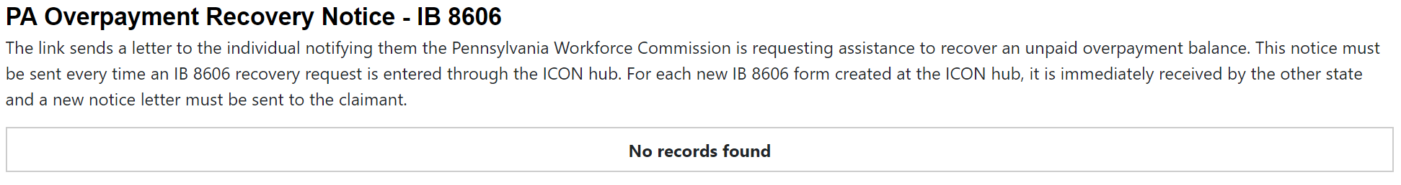

Overpayment Determinations

The Overpayment Determinations screen displays each system generated and IRORA overpayment. Under the “Action” field, click the hyperlink to view the overpayment determination and/or file an appeal to a system-generated overpayment.

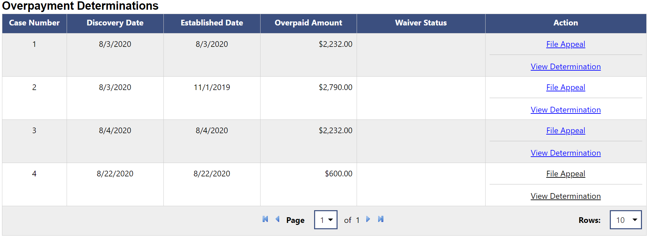

15% and/or Penalty Week Determinations

The 15% and/or Penalty Weeks Determinations screen displays the overpaid amount, the number of assessed penalty weeks, and the 15 percent penalties for system-generated overpayments. Under the “Action” field, click the hyperlink to view the penalty week and/or 15 percent penalty determinations and/or file appeals to them.

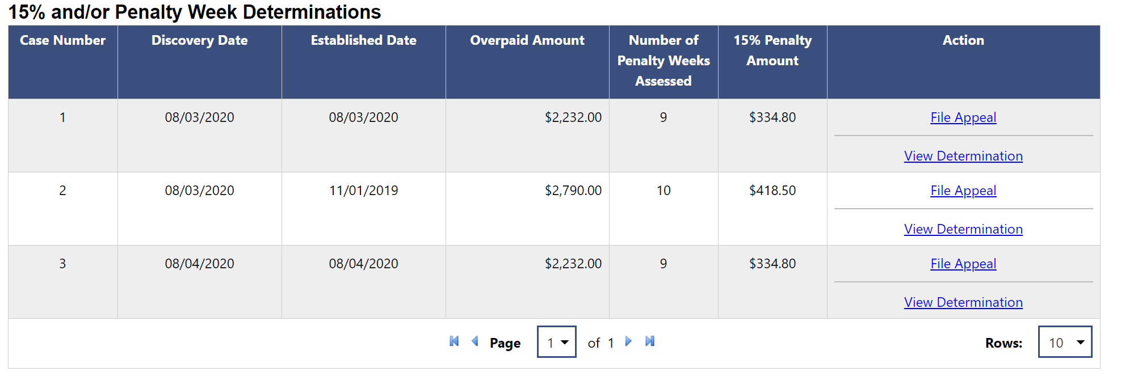

Overpayments Repayments Refund

The Overpayments Repayments Refund screen displays any refunds the department owes to you because you paid too much money towards an original or reduced overpayment.

