How Employers can file Requests for Relief from Charges
Contributory employers and reimbursable employers who paid the solvency fee can request relief from charges when a claimant’s unemployment status is not the result of the employer’s action.
To file a request for relief from charges, log in to your dashboard and locate the “View & Protest Employer Charges” hyperlink that is located on the right-hand side of the page. It is located inside what is called the “Unemployment Services” widget.
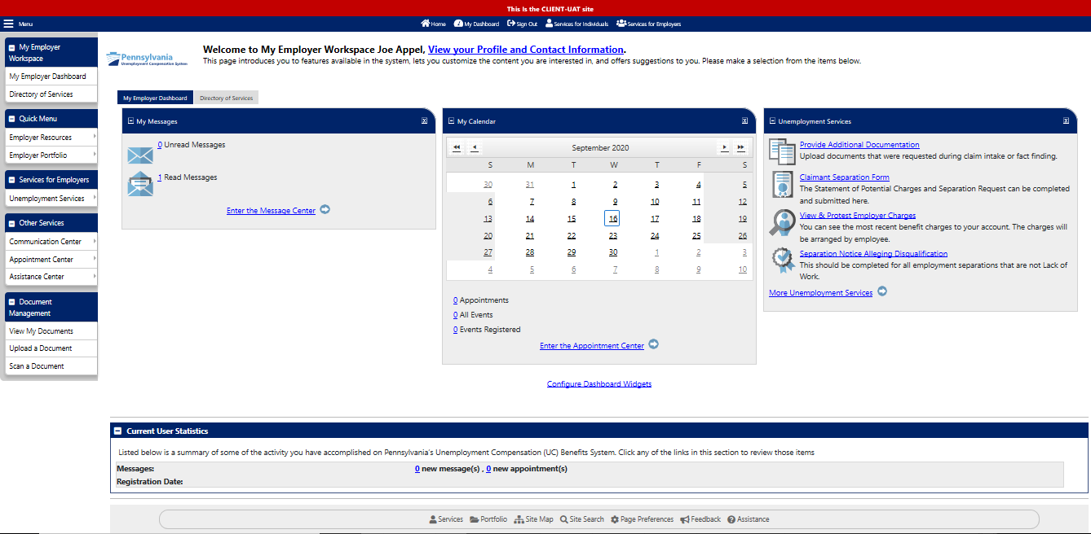

Next, select the “Employer Charges” tab, which is the 1st tab at the top of the screen. Scroll down to the bottom of the page and you will be presented with a list of claimants who are filing for benefits from your company. Find the claimant for whom you would like to file a request for relief from charges. If you are searching for a specific claimant, you can filter by inputting information into the Time Period, Quarter, Last four digits of their SSN, and First or Last Name fields. After inputting information into one of these fields you can narrow your search by selecting the Filter link. With your filtered list, find the claimant for whom you would like to file a request for relief from changes and then select “File Protest,” which is in the “Action” column, located in the far right-hand side of that claimant’s row.
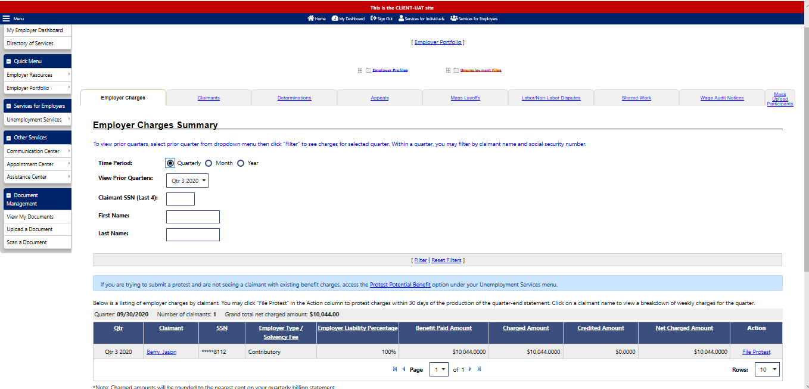

The next page will be the “Employer Charge Protest” screen. On this page, you should verify that you have selected the correct claimant as well as the accuracy of other important information regarding your account.
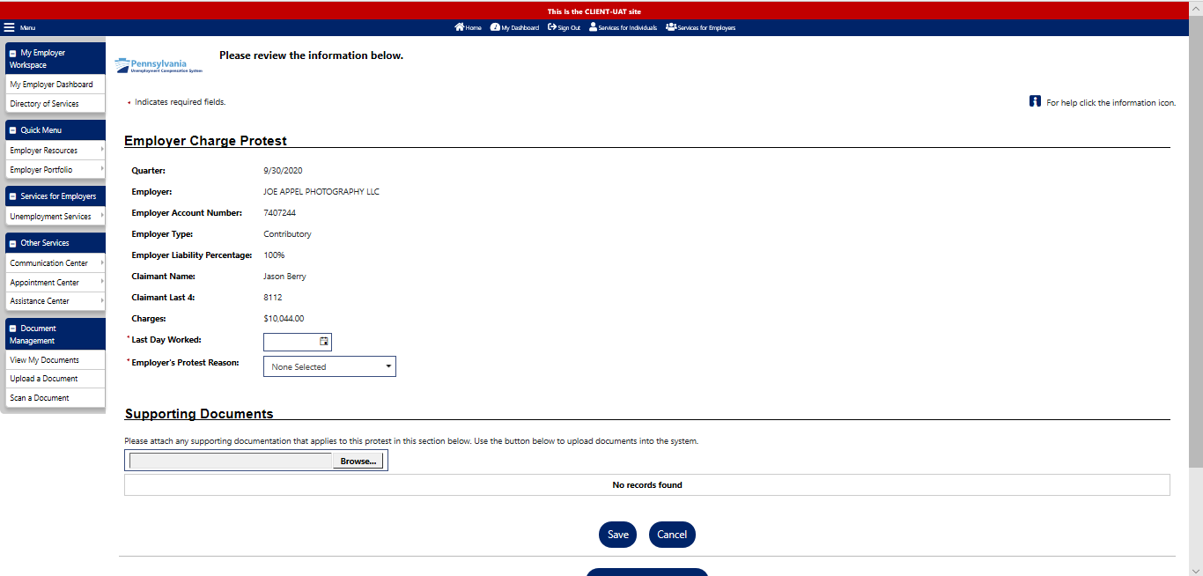

To select the last day the claimant worked for your business, click on the calendar, and select the correct date to add to the field. You can also type the date using the format MM/DD/YYYY.
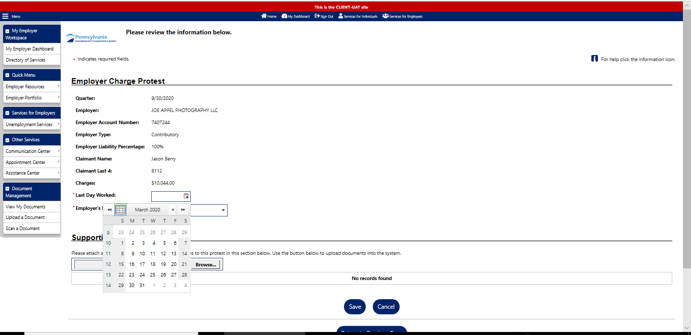

To select the “Employer’s Protest Reason,” click on the drop-down arrow and you will be presented with a list of reasons for why you would like to request relief from charges. The reasons listed are: Claimant Discharged, Claimant Quit, Claimant Still Working, Claimant Never Worked Here, and Disaster. Select the reason by clicking on the one that applies to this person’s situation.
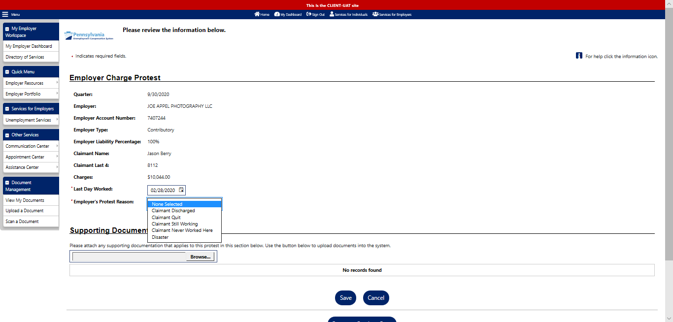

Employer Protest Reason: Claimant Discharged
This is the page you will be presented when you select the “Claimant Discharged” dropdown reason. This page contains a text box field, as well as other questions regarding the separation. All of these are mandatory fields which means that they must be completed to file your relief from charges request.

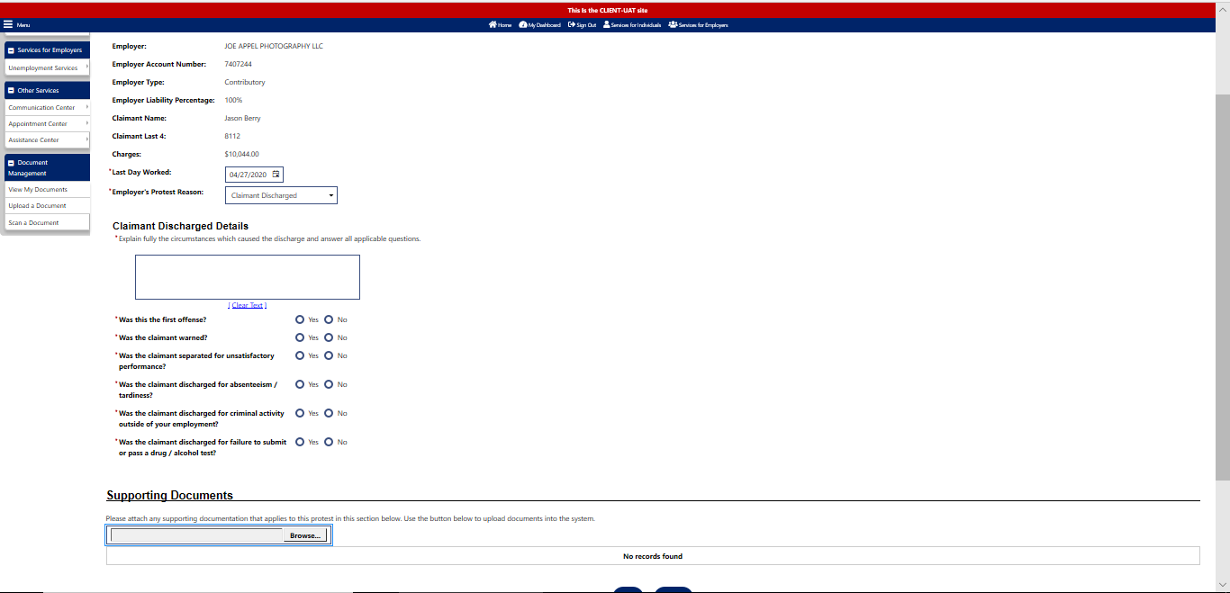

Employer Protest Reason: Claimant Quit
This is the page you will be presented when you select the “Claimant Quit” dropdown reason. This page contains a text box field, as well as other questions regarding the separation. All of these are mandatory fields which means that they must be completed to file your relief from charges request.

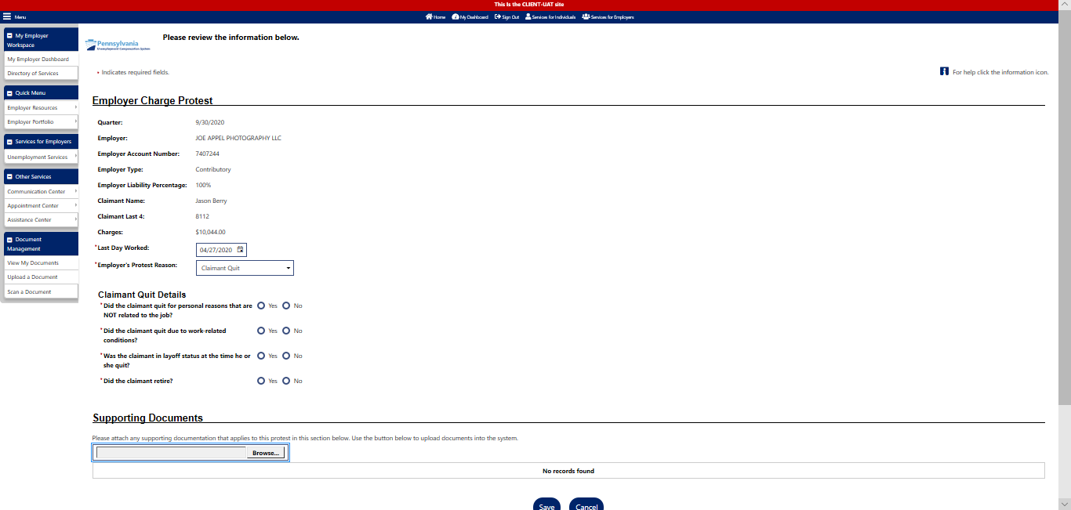

Employer Protest Reason: Claimant Still Working
This is the page you will be presented when you select the “Claimant Still Working” dropdown reason. This page contains questions regarding the separation. All of these are mandatory fields which means that they must be completed to file your relief from charges request.

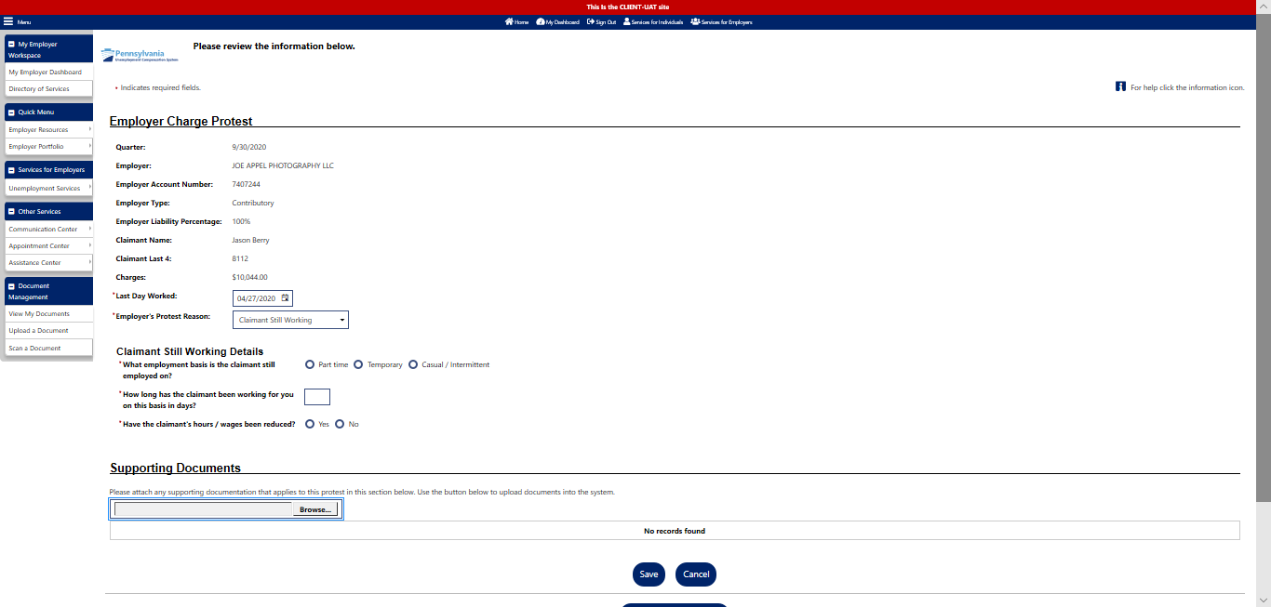

Employer Protest Reason: Claimant Never Worked Here
This is the page that you will be presented with if you select the “Claimant never Worked Here” dropdown reason. If you select the “Claimant Never Worked Here option,” there are no further questions you need to complete.

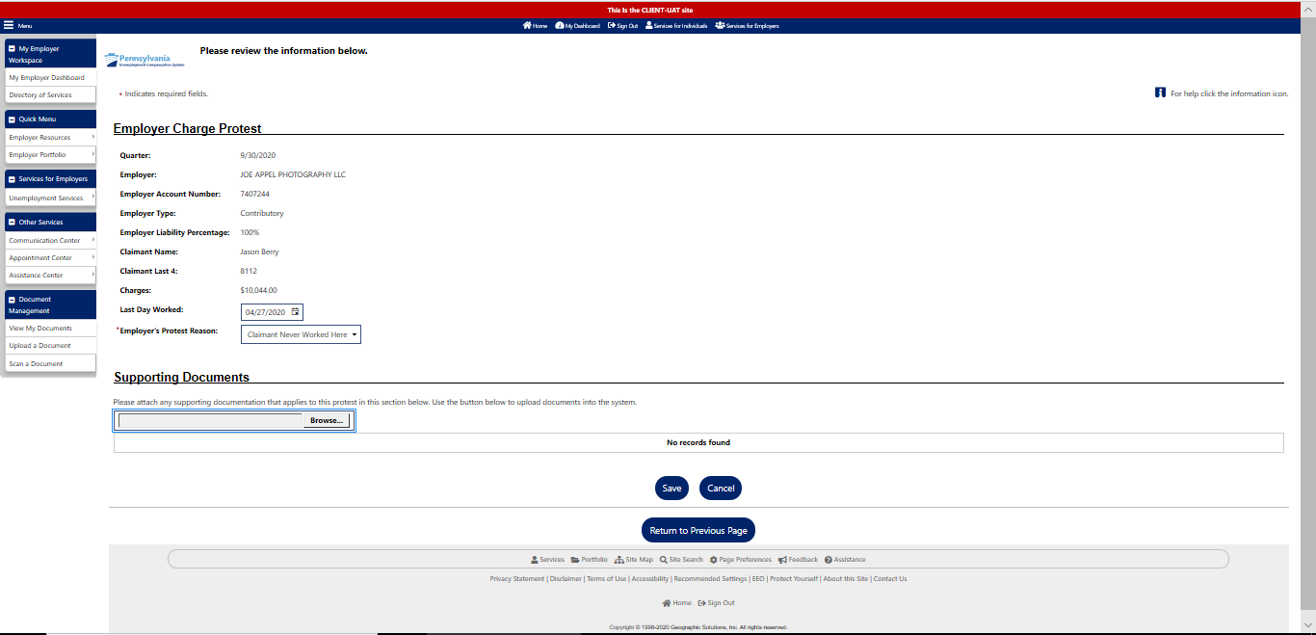

Employer Protest Reason: Disaster
This is the page you will be presented when you select the “Disaster” dropdown reason. This page contains questions regarding the disaster. All of these are mandatory fields which means that they must be completed to file your relief from charges request.

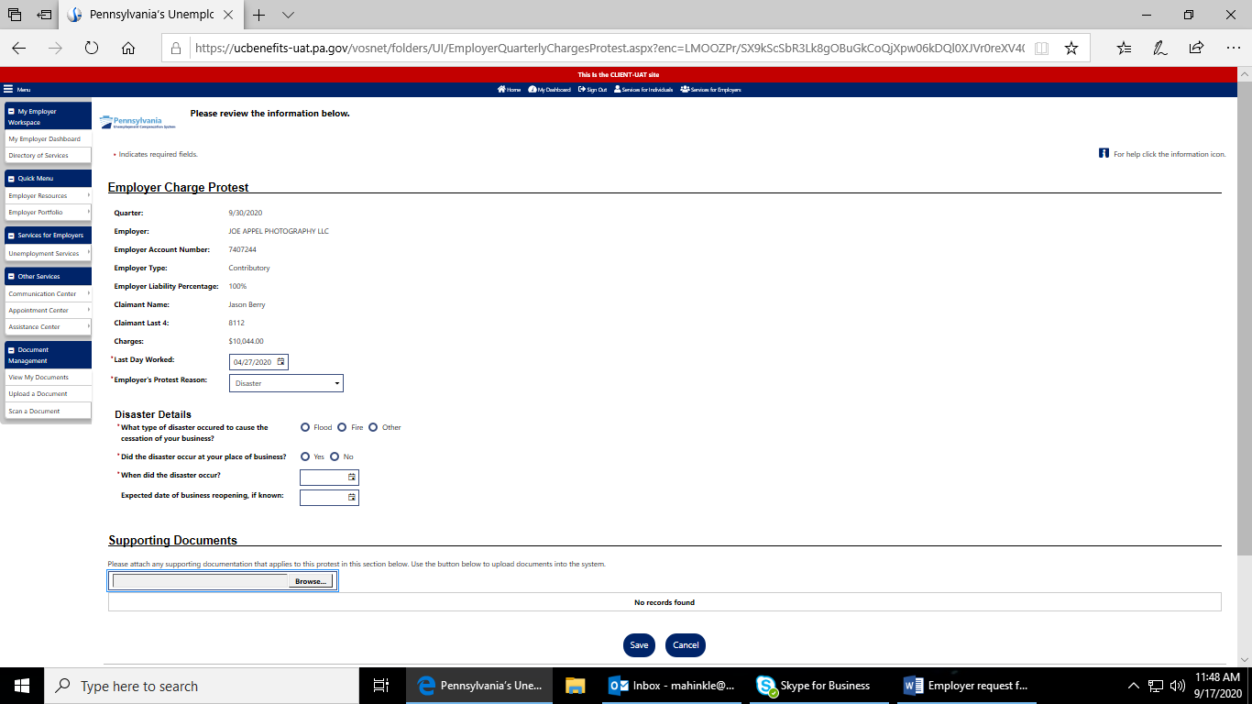

Once you have completed all the required fields regarding your reason for request of relief from charges, you will have an opportunity to upload documentation that supports your request for relief. Scroll to the bottom of the page and locate the “Supporting Documents” section. To upload a document, select the “Browse” button to upload your supporting document from your computer.

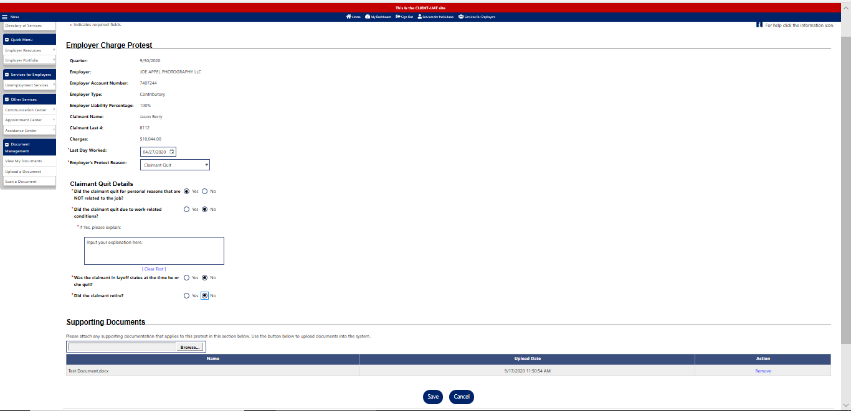

Once you have uploaded all pertinent documentation, the last step to file your relief from charges request is to click the “Save” button.

You will be able to verify that your request for relief from charges was successfully filed.
From the “Employer Charges” tab where you began this process, you will still see the list of claimants which you could originally see in the beginning. If you are searching for a specific claimant, you can filter by inputting information into the time period, quarter, last 4 of the SSN, first or last name field. After inputting information into one of these fields you can narrow your search by selecting the Filter link. Locate the claimant’s name in the list. Instead of “File Protest” at the end of the claimant’s row, the link will now say “View Protest.” You may view the relief request at any time, moving forward.

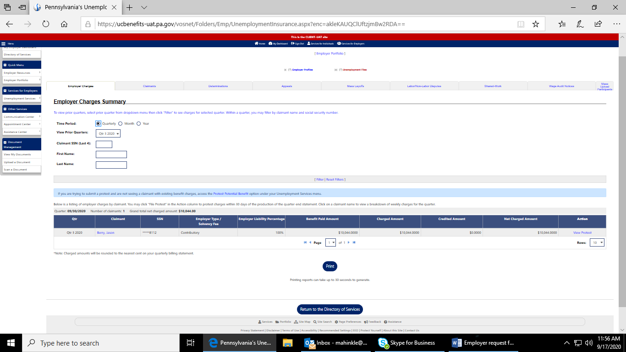

Once you have selected the View Protest hyperlink, you will be presented with a summary screen so you can review your request information.

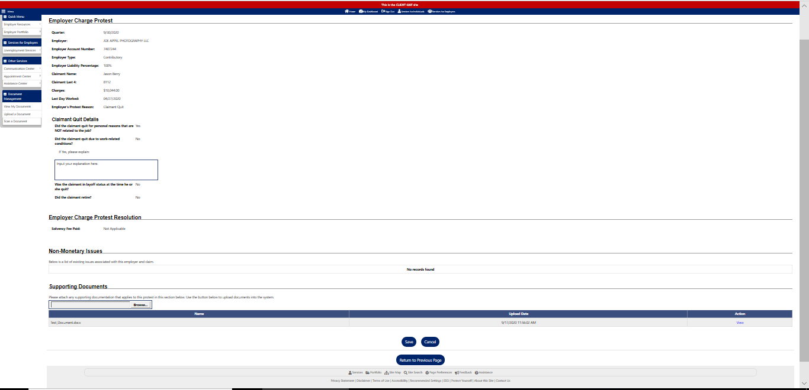

Once you have reviewed your request for relief from charges, you can return to your Employer Dashboard by scrolling to the top of the page and clicking on “My Employer Dashboard” on the left-hand navigation.

